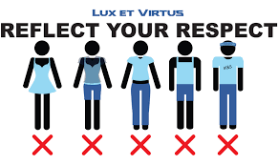

An Advice Column Response Page 73
- Paragraph 1
Problem: how to look fashionable at a school with a dress code
Paragraph 2
What to do: have your own style with the right accessories
What not to do: shouldn’t wear expensive accessories at school
Paragraph 3
My advice: Think carefully about your style and shop for accessories to fit that image.
- t rendy – opinion colourful – colour small – size gold – colour 7 1. She likes expensive, short black skirts.
  - I am wearing big, blue slippers.
  - I hate my uncomfortable, tight black jeans.
  - He always wears trendy, long colourful shirts.

