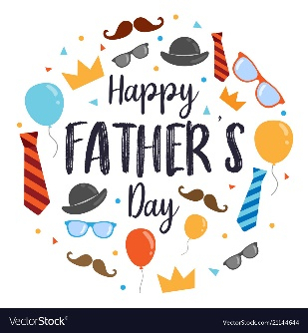SPEAKING Page 54
1) 1. a 2. b 3. a 4. b 5. b 6. b
WRITING
2)
- elegant black

- trendy bright
3. casual loose
4. practical big brown
5. ugly long grey

3) 1. simple little black 2. practical flat 3. trendy long 4. tight black 5. comfortable bright-coloured 6. fashionable long 7. trendy wide
CHECK YOUR PROGRESS Page 55
- 1. d 3. h 5. j 7. b 9. e 2. f 4. g 6. i 8. a 10. c

1 toast 2mural 3. Raw 4. Invisible 5. Helmet 6. path 7. leap 8. archeologist 9. soap 10. Proud

3)
1. shouldn’t
2. have to
3. could
4. can
5. mustn’t

4 )
- can / should
- don’t have to
- can’t
4. couldn’t
5. have to / should

5)
1. bought
2. hasn’t got
3. are you wearing
4. There weren’t
5. How many
6. was searching
7. Is there
8. much
9. wear
10. the hottest

