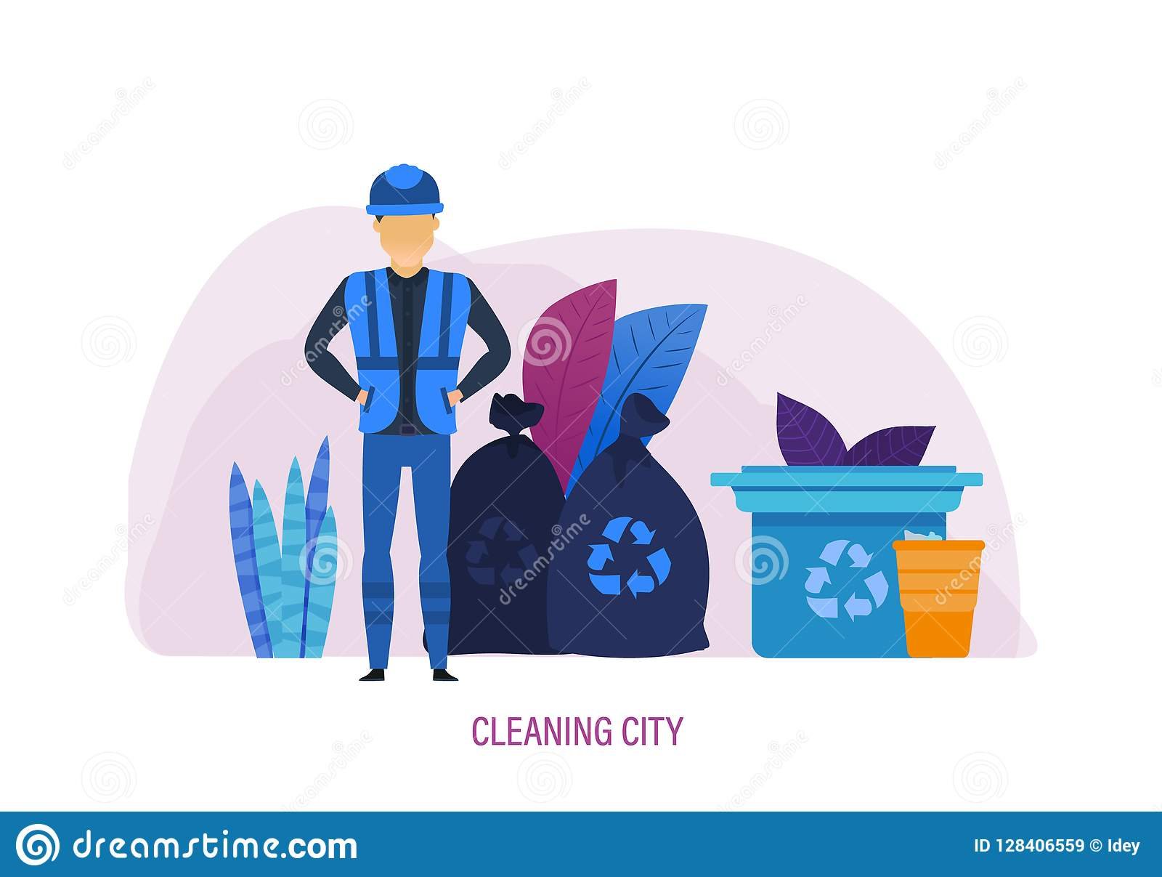

pAge 52

Writing: A report
Work WitH A moDel
2 Par 1. b Par 2+3. a Par 4. c

Zoom in
I suggest
I recommend
3 1. Firstly, In addition, What is more
- However
- This way, As a result

4. To sum up pAge 53 prepAre For yoUr tAsk

5 VOCABULARY AND BRAINSTORMING
Problems: 1, 5, 9
Suggestions: 2, 4, 7 Results: 3, 6,

