16th March, 2020 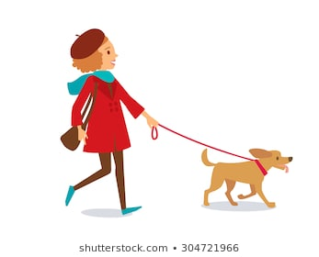
CLASSBOOK EXERCISES PAGES 70 & 71
1)
I hope all of you learn the vocabulary. Do you understand all the words?
DESIGNER ELEGANT LATEST (SUPERLATIVE OF LATE) TRENDY (someone who follows the latest fashion) HOT OUTDATED (old-fashioned looking/ out of style) FASHIONABLE (similar to trendy) TIGHT (a bit small) LOOSE (a bit big for you) FORMAL AFFORDABLE (reasonable price $$$€€€€) COMFORTABLE CASUAL (informal) PRACTICAL
2)
- FALSE. High heels aren’t practical
- FALSE. Affordable clothing isn’t expensive.
- TRUE.
- TRUE.
- FALSE. Tight clothing isn’t too big. Tight clothing is too small.
- TRUE.
3)
Synonyms:
Outdated – Old-fashioned
Trendy—Fashionable/latest/hot
Antonyms:
Tight-loose
Casual-formal
4)
3
5)
- Thanks to fast fashion shops, you can buy affordable copies of trendy fashion items. (lines 5-6)
- These copies are called fast fashion because people can make them quickly (lines 6-7)
- They appear in and disappear from the shops very quickly. (lines 7-9)
- Fast fashion items don’t usually last as long as expensive ones. (lenes 11-12)
- Farmers must use almost 1,500 litres of water to grow cotton for one pair of jeans. (lines 14-15)

6)
- Designer clothes
- Longer than fast fashion items
- Buy affordable copies of trendy fashion items
- 1,500 litres of water
- In recycling bins

