WEEK 1 HOMEWORK 12/03/20 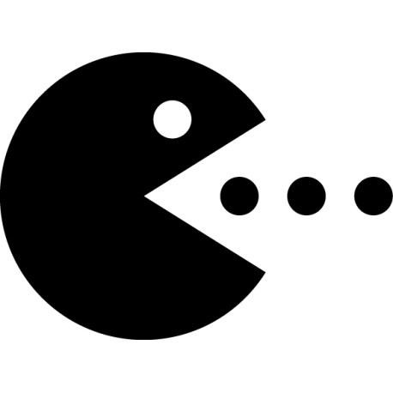
STUDENTS’ BOOK PAGES 68 & 69
Page 68
1)
All logical answers are Okay.
- Parents should/shouldn’t choose their children’s clothes.
- Girls should/shouldn’t have long hair.
- Our school headmaster should/shouldn’t change the rules about clothing in school.
- People shouldn’t only wear only brand new clothes.
- Our teacher should/shouldn’t let us wear caps in class.
2)
- You should always carry a raincoat with you.
- You shouldn’t hike in flip-flops.
- You should take warm clothes.
- You shouldn’t forget sunglasses.
- You should pack a swimsuit.
- You should bring a towel.
3)
- Must buy
- Mustn’t kill
- Mustn’t wear
- Mustn’t walk
- Must try
4 ) and 5)
- You must be at school by 8 am. You mustn’t be late.
- You must wear beige trousers and a blue shirt at all times.
- You must keep your school uniform clean.
- You mustn’t come to school in high heels.
- You mustn’t colour your hair in unusual colours.
- You must leave your mobile phone in your schoolbag during lessons.

Page 69.
6)
- Couldn’t
- Could
- Can’t
- Couldn’t
- Can
- Can’t

7)
- Can your mother walk in high heels?
- Can you run in flip-flops?
- Could your parents wear jeans when they were young?
- Could your grandparents shop online 30 years ago?
- Can you make your own clothes?
8)
- 1a
- 2b
- 3b
- 4a
- 5b
9)
- Should
- Do you have to
- Could
- Can
- Can’t
- Must
- Don’t have to
- Can
- Don’t have to

